**PROJECT REPORT**

**ON**

**JUST SHOP**

**Carried Out at**



**CENTRE FOR DEVELOPMENT OF ADVANCED COMPUTING**

**ELECTRONIC CITY, BANGALORE**

**UNDER THE SUPERVISION OF**

**Mr. N Shanmuganathan**

**C-DAC Bangalore**

**Submitted By**

**R A PRAKHAR (201950120085)**

**RITESH KUMAR (201950120090)**

**RASHI MAZUMDAR (201950120087)**

**ANSHUMAN SINGH RAJPUT (201950120086)**

**PRAVAL PRATAP SINGH (201950120083)**

**PG DIPLOMA IN ADVANCED COMPUTING**

**C-DAC, BANGALORE**

**Candidate’s Declaration**

We hereby certify that the work being presented in the report entitled **Just Shop**, in partial fulfillment of the requirements for the award of PG Diploma Certificate and submitted in the department of PG-DAC of the C-DAC Bangalore, is an authentic record of our work carried out during the period, 1st March 2021 to 29th March 2021 under the supervision of **Mr. N Shanmuganathan**, C-DAC Bangalore. The matter presented in the report has not been submitted by us for the award of any degree of this or any other Institute/University.

**(Name and Signature of Candidate)**

**R A PRAKHAR (201950120085)**

**RITESH KUMAR (201950120090)**

**ANSHUMAN SINGH RAJPUT (201950120086)**

**RASHI MAZUMDAR (201950120087)**

**PRAVAL PRATAP SINGH (201950120083)**

**Counter Signed by**

--------------------

**ACKNOWLEDGMENT**

We take this opportunity to express our gratitude to all those people who have been directly and indirectly with us during the competition of this project.

We pay thanks toMr. N Shanmuganathan who has given guidance and a light to us during this major project. His versatile knowledge about “Just Shop “has eased us in the critical times during the span of this Final Project.

We acknowledge here our debt to those who contributed significantly to one or more steps. We take full responsibility for any remaining sins of omission and commission.

Students Name

**CERTIFICATE**

This is to certify that the work titled **JUST SHOP** is carried out by R A PRAKHAR (201950120085),RITESH KUMAR(201950120090),RASHI MAZUMDAR (201950120087),ANSHUMAN SINGH RAJPUT (201950120086),PRAVAL PRATAP SINGH (201950120083) the bonafide students of Diploma in Advanced Computing of Centre for Development in Advanced Computing, Knowledge Park, Bangalore from 21st September 2021 - 16th April 2022. The Course End Project work is carried out under my direct supervision and 80% completed.

**Mr. N Shanmuganathan**

(Supervisor)

C-DAC, Knowledge Park,

Bangalore - 560038, India

**ABSTRACT**

Internet has become an important medium for doing global business based on the state of the art technology. Global business was conducted in a new way: electronically using networks and the Internet. The availability of Internet has led to the development of E-Commerce in which transaction take place via telecommunication networks.

Just Shop is an online Web portal where a user can visit the website and buy any item based on the category of his choice. When user wants to buy any item he has to Register as a customer first and provide in the details required and then login with the same account details. Choose the Product you wish to buy from the different sections shown in the navigation bar. Select the product of your choice and also its sub category thereby adding the product in the cart. Now you need to buy the product by filling the details of your address. React is used for the front-end, Spring Boot for the back-end, MySQL for the database..

**TABLE OF CONTENT**

1. Introduction …..........................................................................................................................1

1.1 Types of E-Commerce……………………………………………………………….

2. Software Requirement Specification………………………………………………………....

2.1 Product Perspective………… ………………………………………………….......

2.2 External Interface Requirements……………………………………………………

3. Architecture………………………………………………………………………………......

4.1 ……………………………………………………………......

4.2 …………………………………………………………….…

4.3 ……………………………………………………………………......

4.4 …………………………………………………………………….

4.5 ……………………………………………………………………......

4. System Design……………………………………………………………………………....

4.1 Class Diagram ……………………………………………………………....

4.2 …………………………………………………………………..….

4.3 ………………………………………………………..

4.4 ………………………………………………………….

5. Detailed Description of Pages

6 USED TECHNOLOGY………………………………………………………………………

5.1 Front-end Side……………………………………………………………………………

5.1.1

5.1.2

5.1.3

5.1.4

5.2 Back-end Side……………………………………………………………………………

5.2.1

5.2.2

5.2.3

5.2.4

7. SYSTEM ARCHITECTURE MODEL………………………………………………………

7.1 Back-end Side

7.2 Front-end Side

7.3 Data Flow Model of the Web Page

8. IMPLEMENTATION…………………………………………………………………………

8.1 Deployment……………………………………………………………………...

8.1.1 Back-end and Front-end Side……………………………………………..

8.2 Implementation………………………………………………………………….

9. Conclusion… ……….…………………………………………..…………......…….…....... ..

10. References……………………………………………………………………….…………….

**CHAPTER 1**

**INTRODUCTION**

Over the past decade, consumers have continuously changed the way they want to shop, especially in terms of shopping behavior on e-commerce channels and websites, forcing businesses to find ways to adapt to this trend. With the support of newest technology, it is easier for consumers to find, compare and purchase from online websites, e-commerce markets, mobile applications, and physical stores and social sites, rather than following traditional commercial models.

Nowadays, the world of e-commerce is developing very strongly. Digitalization helps people to save more costs transported through intermediaries, transaction costs and it significantly helps to save time to invest in other activities. Customers can sit at home and buy everything they want without physically visiting the shop. Therefore, the topic: “Just Shop” was selected for this project.

According to research by Get App (Factory 2021), the leading review software in the world, they have given the following Figures about consumer needs and habits of cus- tomers:

* + - Customers like to research and buy products online with 53.1%.
    - Customers prefer to research online and buy offline with 28.9%.
    - 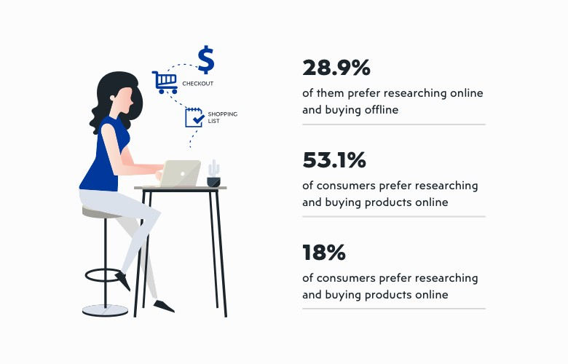Only 18% of customers say they prefer to going to stores.

**Figure 1**. E-commerce Research (Factory 2021).

## 1.2.1 **Four Types of E-commerce**

## B2C:BUSINESS TO CONSUMERS

B2C e-commerce includes transactions made between businesses and consumers. This is one of the most widely used sales models in the e-commerce landscape. For example, when customers buy shoes online from the manufacturer Nike, this is a business-to-con- sumer transaction.

## B2B: BUSINESS TO BUSINESS

B2B e-commerce involves commercial activities carried out between businesses, such as between manufacturers and dealers or retailers. Typically, business-to-business sales will often focus on raw materials, or packaged products.

## C2C: CONSUMER TO CONSUMER

One of the earliest established e-commerce business models is the C2C e-commerce business model. This includes customer-to-customer relationships, for example on Shopee, Amazon, and Lazada, Alibaba.

## C2B: CONSUMER TO ENTERPRISE

C2B is a business model that reverses the traditional e-commerce model. C2B means the individual consumer produces the product or service, the business will be the one

who buys it.

**CHAPTER 2**

**SOFTWARE REQUIREMENT SPECIFICATION**

**3.1 Product Perspective**

Requirements for an e-commerce website to meet the needs of customers in terms of support as well as ensure the basic criteria of buying and selling products on an e-com- merce site. The requirements of this website are listed below:

## 3.1.1 Requirements for end-user perspective are the following:

* + - Product information :
      * Product is always updated, introducing the latest generation.
      * Information about a product must be detailed so that customers can grasp information about the product they choose. Especially the items that many customers are interested in.
      * Allows customers to search quickly and accurately according to many criteria.
    - The interface is easy to use and highly aesthetically pleasing.
    - Allow customers to register and ensure confidentiality of information
    - View and change account information.
    - Payment methods must be accurate.

## Requirements for admin perspective are the following:

* + - General management: related information of Seller, Customer.
    - Updating items information online.
    - Easily update and regularly change pictures, details, prices of the items for sale regularly changed.
    - Manage online orders.
    - Admin page store activities associated with customers of the store. All the activities related to customers and customers can be done remotely, re- gardless of geographical location.
    - Statistics of which items are sold out.
    - Synthesizing storing feedback from customers so that customers can re- spond to customers quickly and accurately.
    - Products: Can add, edit and delete information, categories
    - Receive and respond to customer requests.

**3.1.3 Operating Environment**

**Server Side:**

Operating System: Windows 10 or above.

Processor: Intel i5 3.0 GHz or higher

**Client side**:

Operating System: Windows 10 or above.

Processor: Intel Atom Processor Z2520 1.2 GHz, or faster processor.

RAM: 4 GB or more

**3.1.4 Design and Implementation Constraints**

* The time allotted for this project is limited to 2-3 months.
* The language for this project is React and domain environment will be embedded in Network.
* Programming is done in React and Spring boot

**3.2 External Interface Requirements**

**3.2.1 User Interfaces**

GUI along with Real time graph implementation

Front-End (software): React JS

Back-End(software): Spring boot

**3.2.2 Hardware Interfaces**

**Server Side:**

Operating System: Windows 7 or above, Android Engine

Processor: Intel i5 3.0 GHz or higher

RAM: 12 GB or more

Hard Drive: 50 GB or more

**Client side:**

Operating System: Android Platform 4.2 or above.

Processor: Intel Atom Processor Z2520 1.2 GHz, or faster processor.

RAM: 2 GB or more

**3.2.3 Software Interfaces**

Front End – Html, CSS

Back End – Java, JavaScript, Socket programming

Server - Tomcat 8.0

BIND 9, Snort, Wireshark

**CHAPTER 7**

**SYSTEM ARCHITECTURE MODEL**

## 7.1 Back-end Side

The Three Tier Architecture model is very popular in Spring Boot. The presentation layer is the communication layer with the end user. All data sent from the server to the client parallel here only checks the correctness of the data. In REST, three tier has the HTTP Method like GET, POST, PUT, DELETE with the purpose of getting data, add- ing data, updating data, deleting. The Controller contains all the logic of the program. Moreover, theData access layer interacts with the database, returning the results to the business logic layer (Controller). Specifically, the project is divided into 3 floors (tier or layer) as shown in Figure

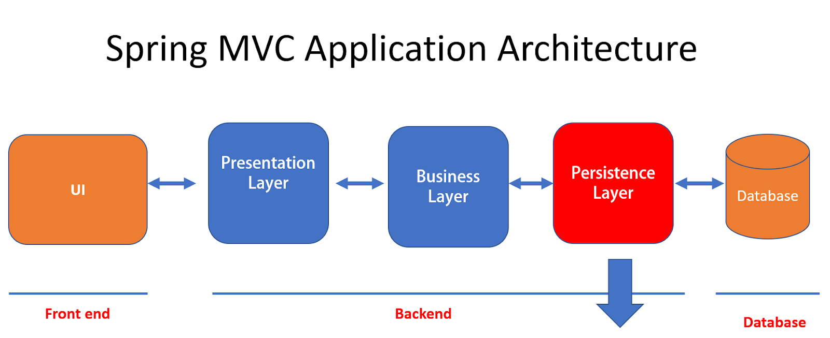

**Figure :** Three Tier Architecture.

## 7.2 Front-end Side

React is a JavaScript library. React has no constraints in the project directory layout and structure. React gives the freedom to refer to different methods and to apply appropriate. Below Figure illustrates the structure of React. Js in the project.

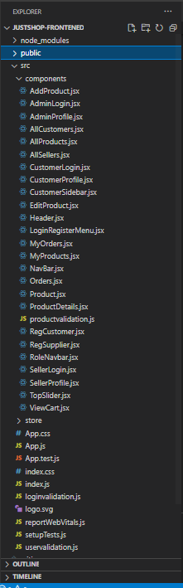

React.Js Structure. The

Operating principle of Redux is illustrated in Figure 7

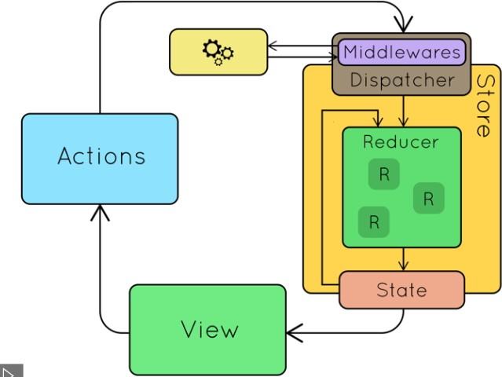

**Figure 7**. Redux Architecture (Reduxjs 2021).

Figure 8 shows the Action file: the action sends information from the application to the Store, describing what jobs will be done with this store. This information is an object describing what happened. The action consists of two parts, the type which describes the action and the value of the parameter passed.

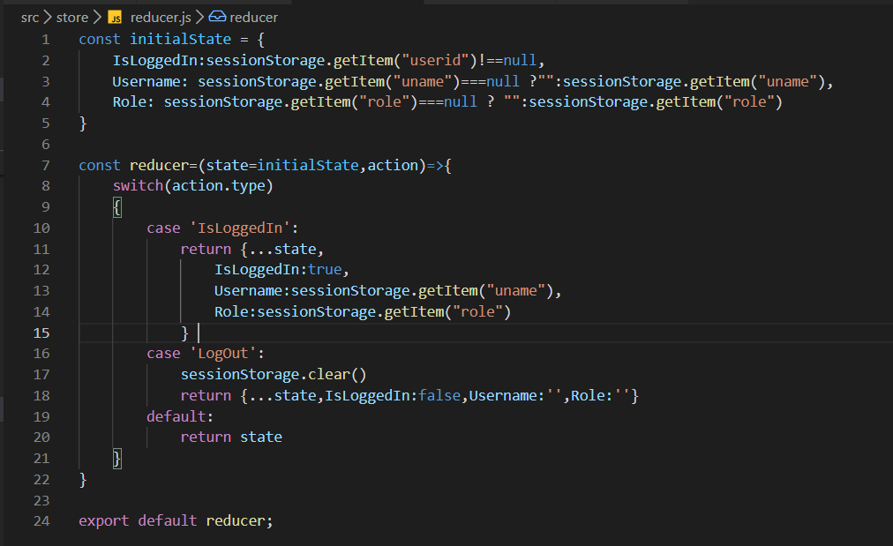

**Figure 8**. Reducer File.

Figure shows that the store is an object that stores all state of the application, access state via getState (), update state via dispatch (action). The store contains a dispatcher which is responsible for implementing actions inside the reducer; the reducer is respon- sible for handling incoming actions. When an action is executed, the dispatcher is im- plemented and sends an action to the reducer. The reducer now takes action based on the action sent. At the same time, the value of the new state is saved in the store and that new state returned. The dispatcher is the middleware manager, usually used to call APIs, logs.

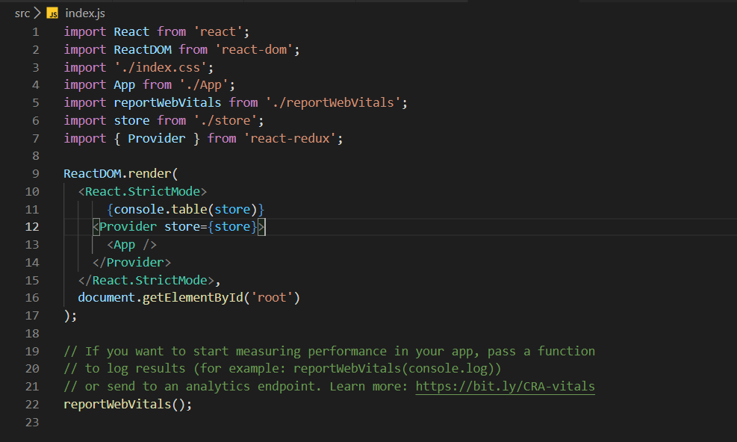

Figure 10. Store.

## 7.3 Data Flow Model of the Web Page

The data flow model of the web site is shown in Figure 11. First the user will go to View to view and interact on the page. When the user starts to load data, for example, by clicking the Reload button, a request from View is sent to the Controller. The Con- troller receives the request and begins to ask service (in the code is called the method of Service). The Service receives the request from the Controller, for a simple code that can be calculated and returned. But for operations that need to touch the database, the Service must call the Repository to get data in the database. The Repository receives a request from the Service, will manipulate DB. The data retrieved from the database is mapped by the Object Relational Mapping system (like JPA or Hibernate) into objects (in Java). These objects are called Entities.

The Service receives Entities returned by the Repository. The transformation here is able to perform calculations, add or remove fields, and finally return Entity via the Model. The Model will be returned to the Controller. The Controller receives the Model

and returns to the View. There are two ways, one is to use the template engine to pass Model data into the HTML page, and then return the HTML department (already with the data) to the client.

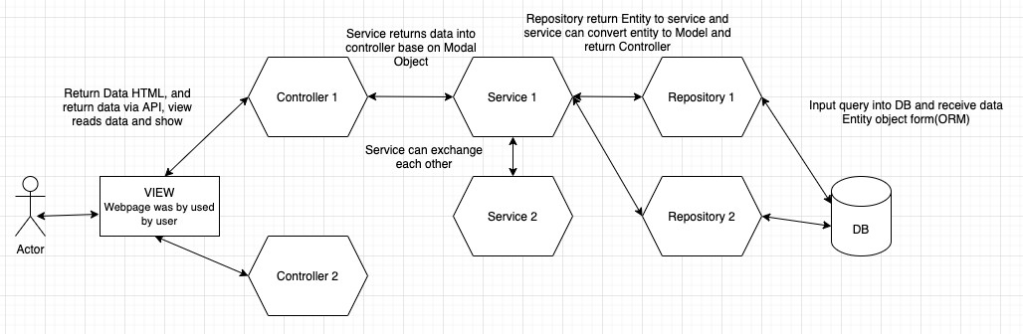

**Figure 11**. Data flow model.

**CHAPTER 8**

**IMPLEMENTATION**

## 8.1 Deployment

## Back-end and Front-end Side.

* + - 1. Swagger UI

Swagger UI is a tool that allows anyone - from developers to end users - to visualize and interact with project API resources. This tool automatically generates API documents from the Swagger config file, with a visual view and easier client-side deployment. Figure shows all APIs that were implemented for E-commerce Just shop.

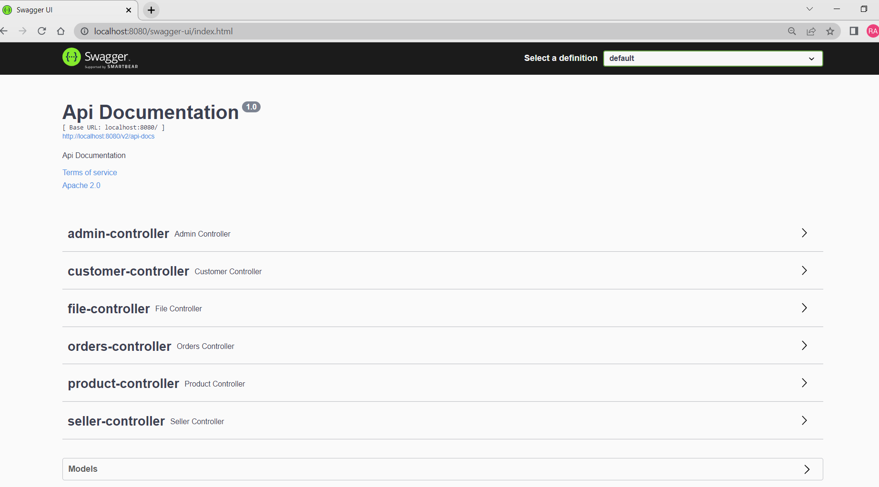

**Figure 43.** Swagger UI

## 8.2 Implementation

a) User Register

The class save method to create a new user is shown in Figure 44. When user enter all the necessary information which were required and click on submit. The user information will be saved to database. Class method is shown in Figure which used to validation information before register such as name, password and email.

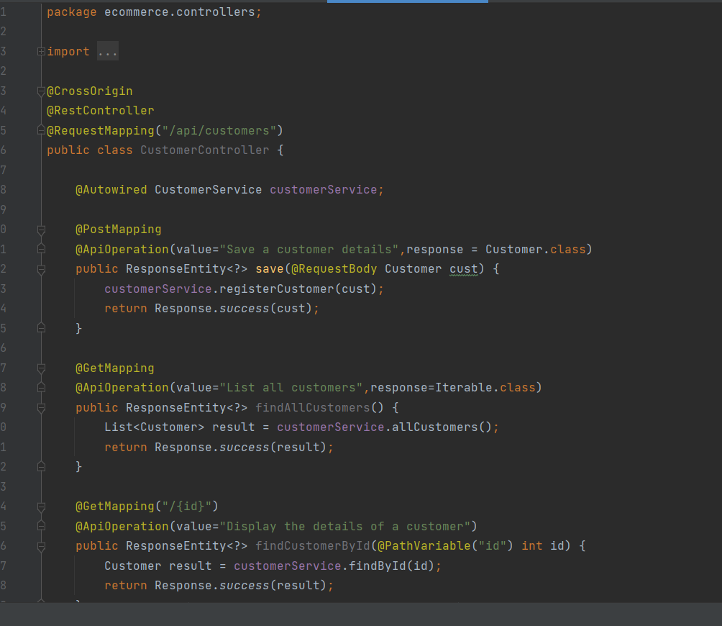

Figure Method for Customer Registration.

b) Login User

The method to login the web-page using UserId and password is shown in Figure. This is the method to login by using UserId and password.

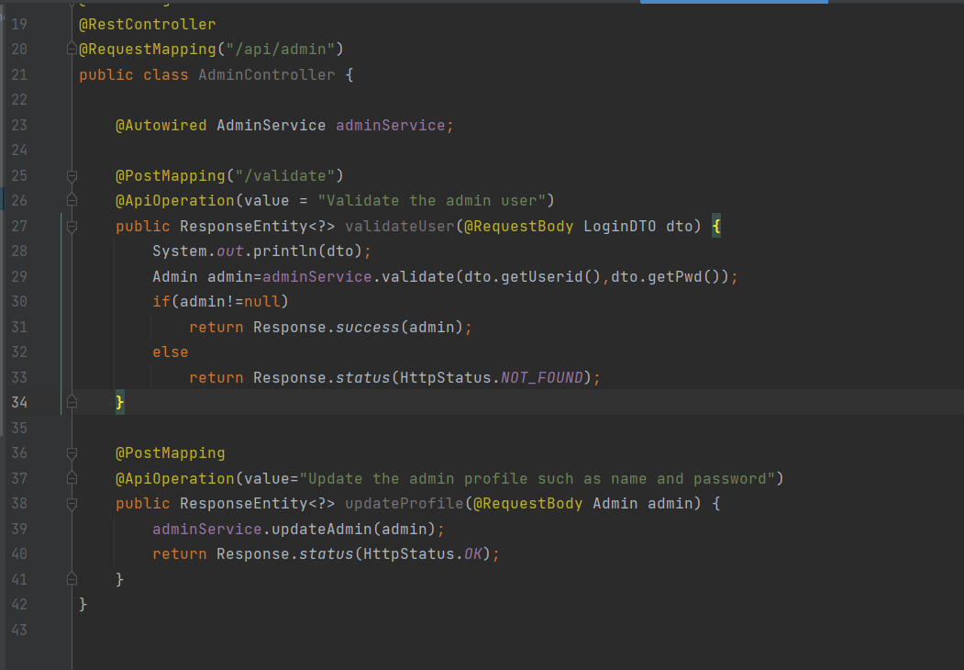

c) Add Product

The method to add product when admin would like to add more products to the web-page. This method requires the admin have to login to the management page and press the add product button, when filled in, the information will be saved to the database.

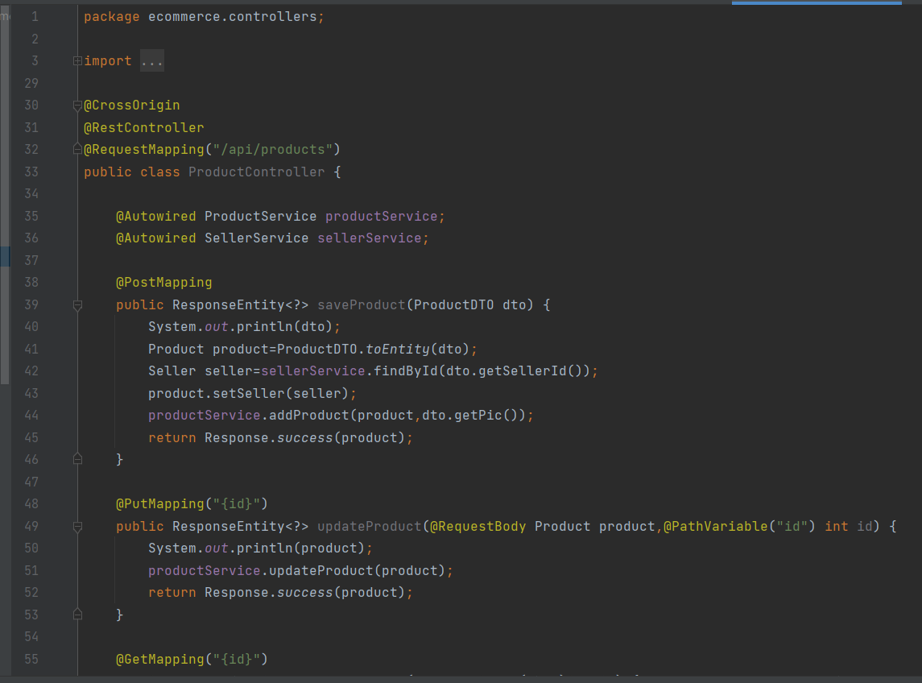

d) Order Product

The method is to order product when user would like to order a product on the web- page is shown in Figure 56. Method saves order information to the database when the user presses the checkout button to pay and will subtract the quantity in stock.

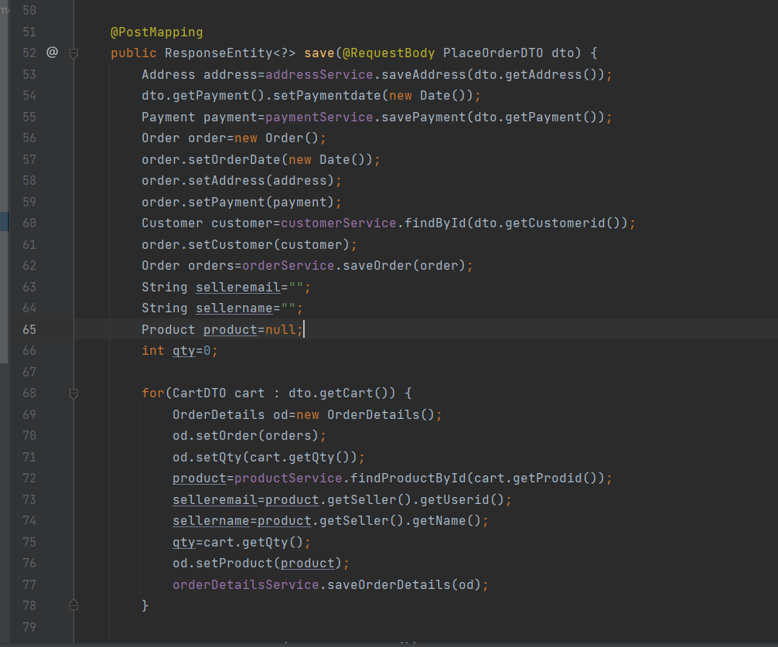

**Figure 56.** Method for order product.

e) Upload Files

The method is to upload files when admin would like to upload image of product on the admin-page is shown in below Figure. The method uploads the image name and hexa decimal value to the server and store image in static folder of Spring Boot.

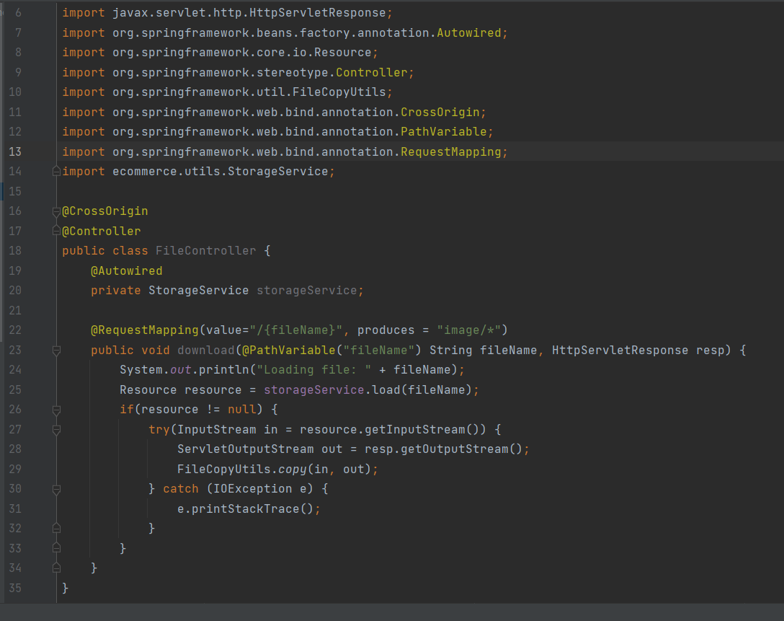

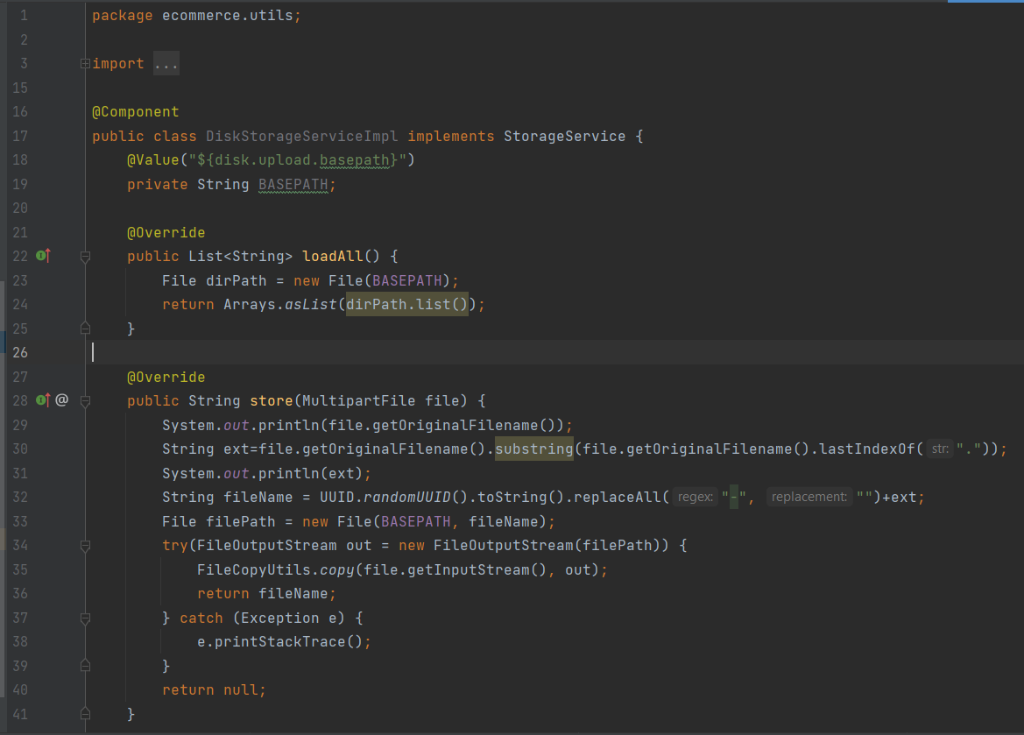

**CHAPTER 8**

**SYSTEM DESIGN**

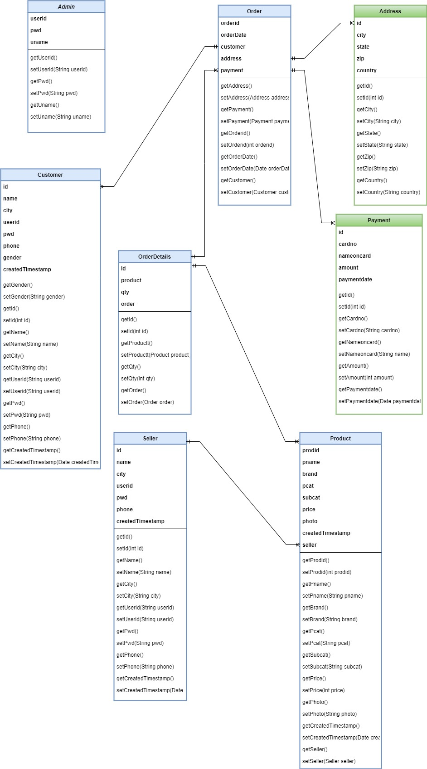 Users: The user table is responsible for containing the necessary information when start- ing to register a member of a website. The fields in the user table are suitable for each user's role.

Roles: The roles table is used to store role information and the roles table has a rela- tionship with the users table to determine which role each user belongs to.

Order: The order table is used to store order information, including shipping infor- mation fields, such as name, address, and phone number when a user starts an order from the website.

Products: The products table is used to store information of a product including fields such as name, price, and quantity. The field information in the product table is relevant for the different product categories.

Rating: The rating table is used to contain user rating information about the product.

Categories: The product category table is used to contain product type information in- cluding field name and category type codes. All category type codes are unique.

Store: The store table is used to store all store information for each branch.

Brands: The product brand table is used to contain manufacturer information and all manufacturer-related information such as image and the manufacturer's name.

## 5.2 Sequence Diagram

## **5.2.1** Login

The sequence diagram in Figure 13 shows sequences in login-functionality. First of all, the user will enter the email and password, and then click on the login button. The system will check that the email and password in the database are correct. If the login is not

successful, the user will need to log in again. In case the user logs in successfully, the system grants permissions to access the feature of the website, the user can use the func- tions in the website.

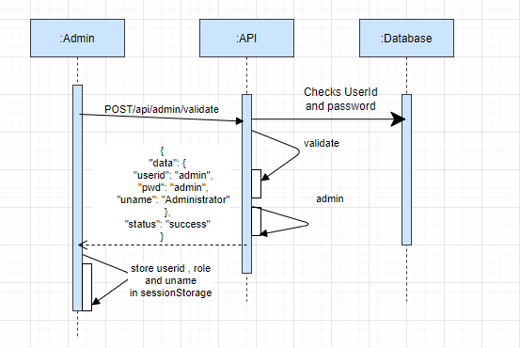

**Figure 13**. Login.

## Logout

The sequence diagram in Figure 14 shows the sequence in logout functionality. The user can log out from the account by clicking the logout button. After the user logout, the system will automatically redirect the user to the home page.

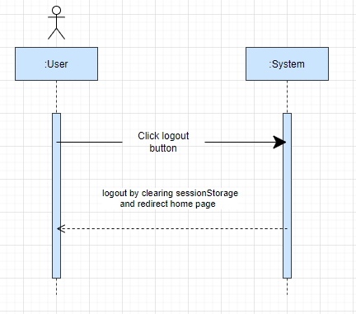

**Figure 14**. Logout.

## Changing Password

The sequence diagram in Figure 15 shows the steps to change the password. The user must login to the system before the user is able to change the password. The web page has a link to change the password. The user clicks the link and fills in the old password, the new password and confirm password -fields. Finally, the user submits the form and the notifications will announce the successful change of the password successfully.

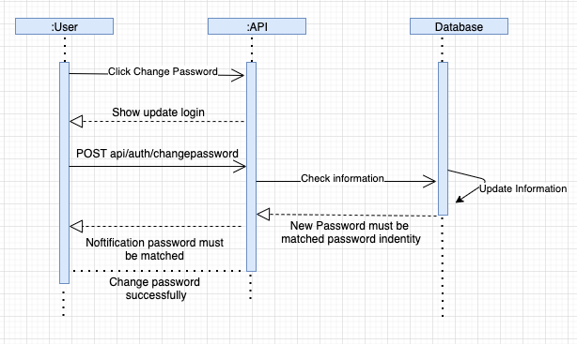

**Figure 15**. Change Password.

## Add Product

The sequence diagram in Figure 16 shows the steps to add a product. The seller must login to the JustShop website and click the add product button to enter the product in- formation. If the product information is wrong, the system will notify the seller to enter the information again. The system will save the product to the database when the infor- mation is correct.

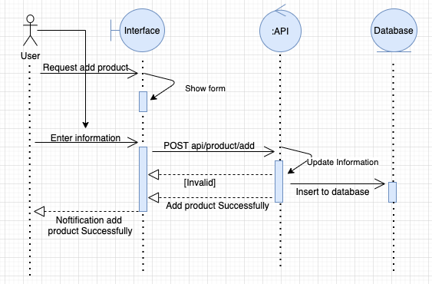

**Figure 16**. Add Product.

## Update Product

The sequence diagram in Figure 17 shows the steps to update a product. The staff must login to the management page and click the update product button to be able to edit product information. If the update information is wrong, the system will notify the user to enter the information again. The system will update the product to the database when the information is correct.

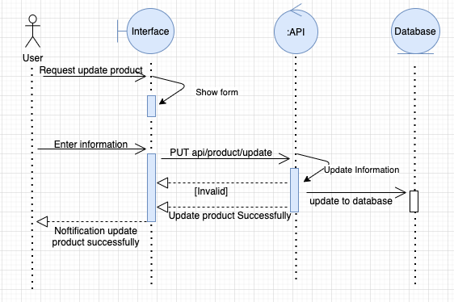

**Figure 17**. Update Product.

## Add User

The sequence diagram in Figure 20 shows the steps in adding a user. The user accesses the account registration page to fill in the account information. If the account infor- mation is valid, it is updated to the database. In case, the information is wrong, the sys- tem will request to review the account information.

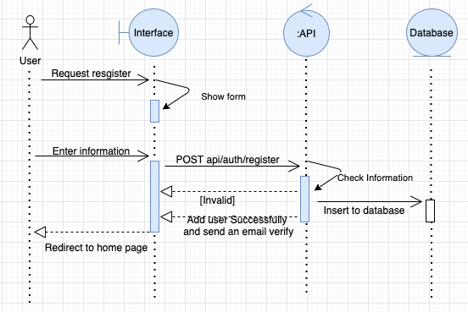

Figure 20. Add User.

## Assign Role.

The sequence diagram in Figure 21 shows the steps in assigning roles. The Admin logins to the system to decentralize accounts for users. Admin is allowed to grant per- missions for the role manager and the author permissions for the product management. After the admin adds, modifies and deletes accounts for the user and if that account in- formation is valid, it is allowed to update the database.

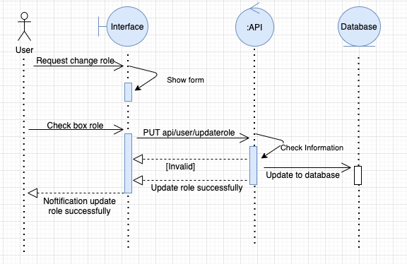

**Figure 21**. Assign Role.

## Order

The sequence diagram in Figure 23 shows the steps in order confirm. The user needs to login to the system to make the payment; the user clicks check out button and needs to fill the information before starting payment for the user’s order. If the user information is wrong, the system will notify the user to enter the information again. The system will send an email to the user when the information is correct.

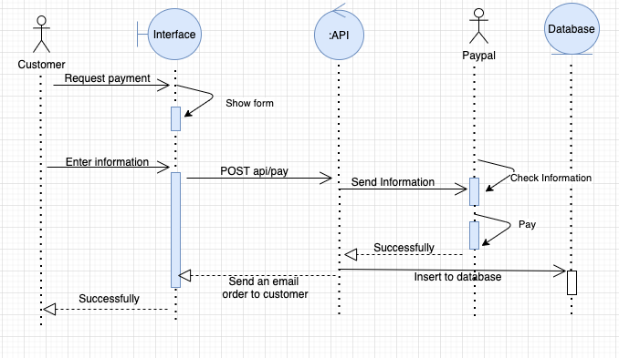

**Figure 23**. Order and Payment.

**CHAPTER - 7**

## **Detailed Description of Pages**

## Login

The Login page which is shown in Figure allows users to log in to the websites using user id and password when user wants to order products through websites store. After successfully logging in, the user can buy products. Basically, we have three types of login:

* Admin
* Seller
* Customer

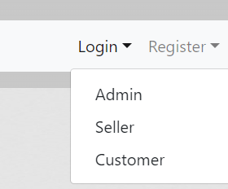

Figure: Types of Login

**Admin Login Form**: Fill in the details if you are Admin

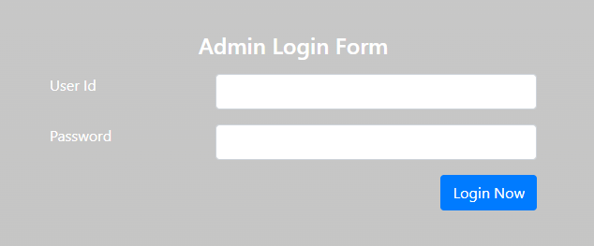

**Figure** : Admin Login Page

**Seller Login Form**: Login as Seller

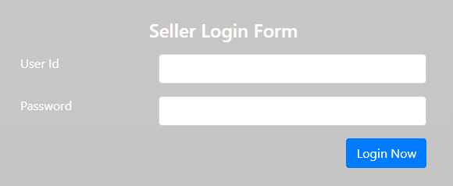

**Figure** : Seller Login Page

**Customer Login Form** : Login as a Customer

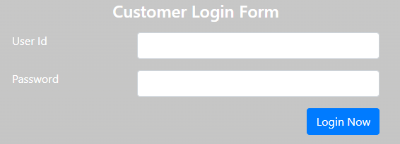

**Figure**: Customer Login Page.

## Seller Products Page

The seller product page which is shown in Figure allows sellers to manage products data and also gives the authority to add, Edit and Delete products. After success- fully logging in, seller has control data related to product.

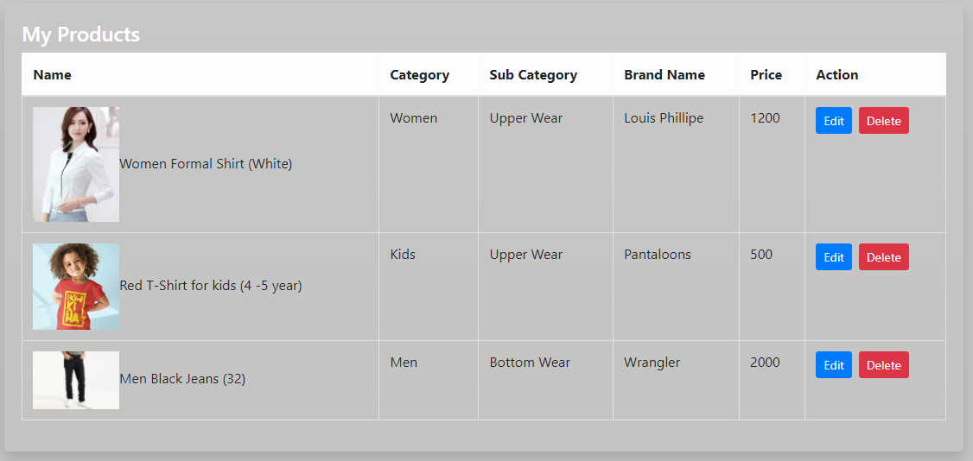

**Figure:** Seller Products Page.

## Seller Register Page

The register page which is shown in Figure allows user to register as a seller. After successfully register, Seller can login with the credentials entered and add the products he wants to sell .

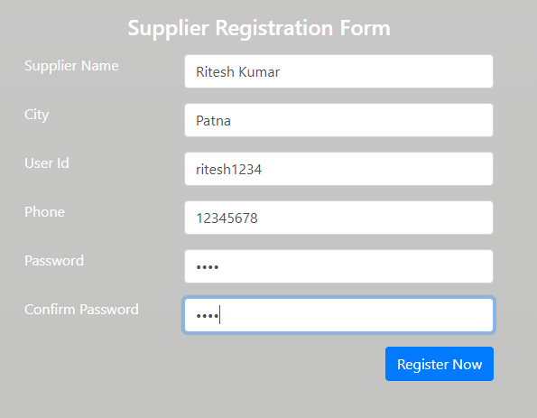

**Figure 28**. Seller Register Page.

## Seller Profile Page

After Successful login of Seller, a profile page will open which will display the details related to Seller as shown in figure.

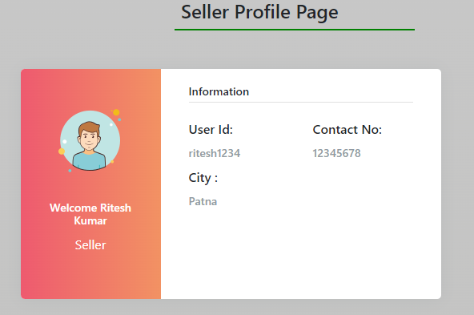

**Figure :** Seller Profile Page.

## Add Product Page

The Add page, which is shown in Figure allows admin to add through websites seller.

Input: product information.

Output: If the product information is correct, the seller will be received notification.

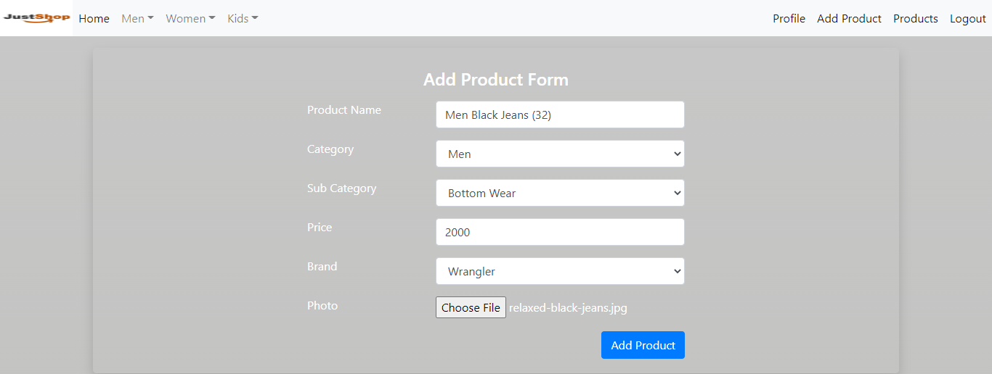

**Figure**: Add Product Page.

## Admin Page

The category page which is shown in Figure 30 allows admin to manage categories data for some methods such as add, update and remove categories through websites admin. After successfully logging in, admin has full control data of website.

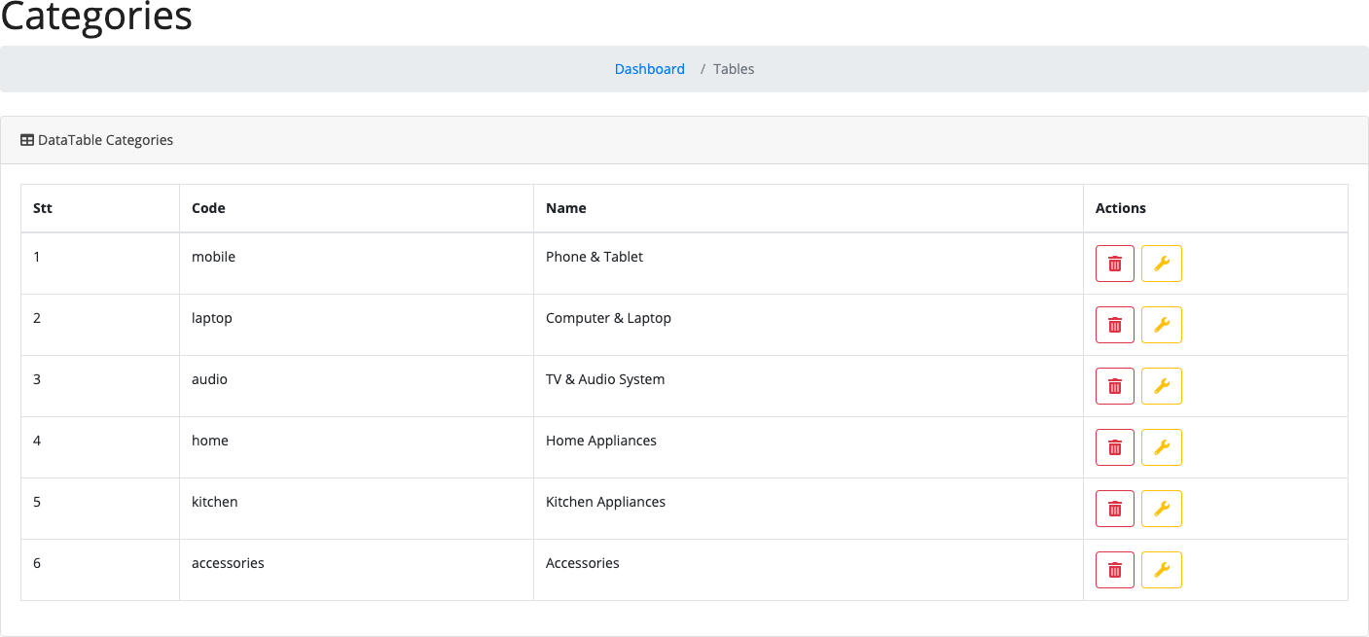

**Figure 30**. Categories Admin Page.

## Admin Profile Page

After successful login admin can view customers list and also the orders and can view and edit the sellers and even it can delete the sellers if required.

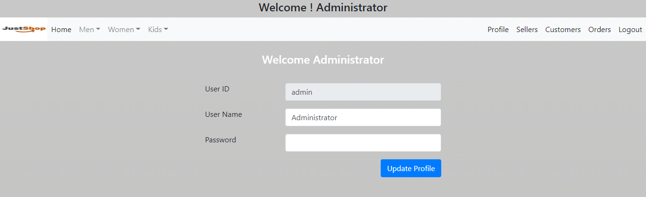

## AllSeller Page

The AllSeller page which is shown in Figure 32 allows admin to manage the sellers. To start assign role for user. The admin need to login the admin page and click the button update which shown in Figure 31.

Input: Check box role.

Output: The system shows a notification.

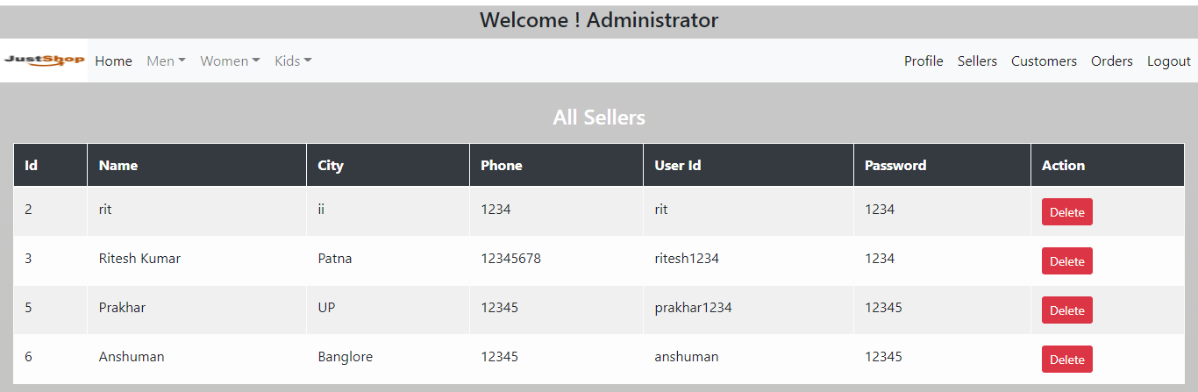

**Figure 31.** AllSeller Page.

## Admin Customer Page

**Comment --- yet to be edited**

The room page which is shown in Figure 33 allows staff who can reply the message when client send messages.

Process: The system will receive any message from user when client has question by us- ing socket manager.

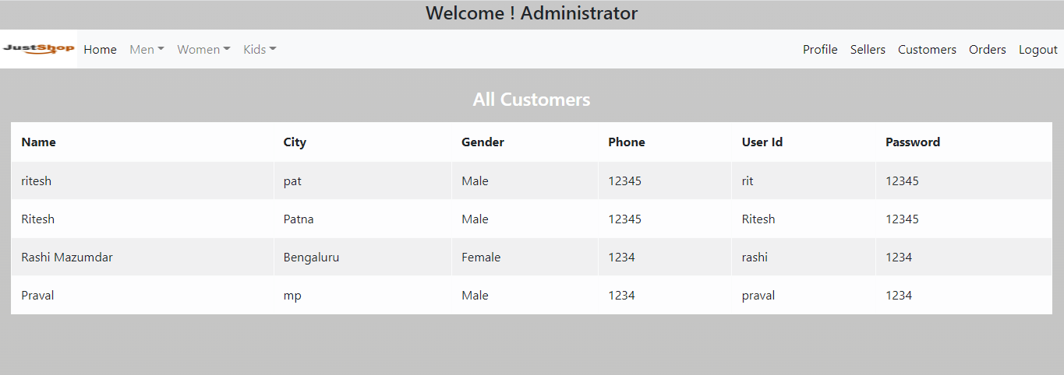

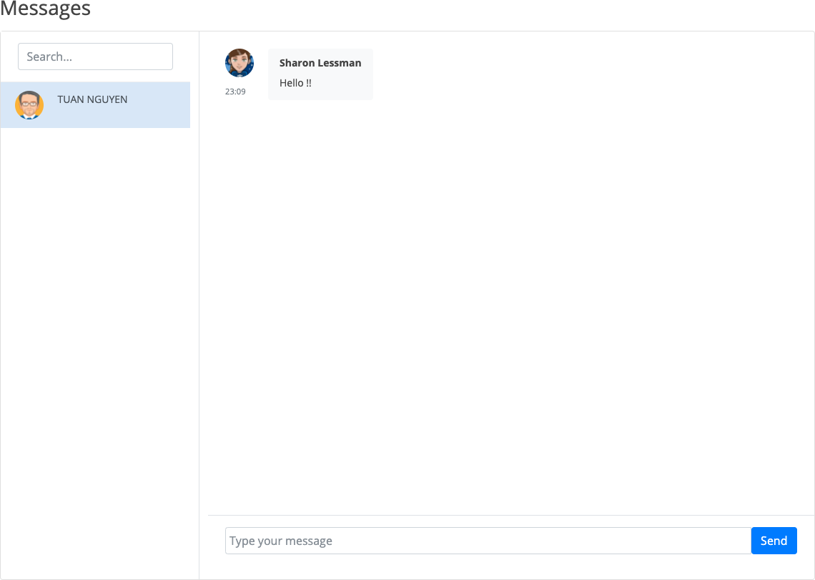

**Figure 33.** Room Page.

## Categories List Page

The category list page which is shown in Figure 34 allows admin to manage categories data for some methods such as add, update and remove categories through websites ad- min. After successfully logging in, admin has full control data of website.

Input: Email, password.

Process: Enter your username and password and check if the username and password are valid.

Output: If the username and password are correct, the admin can use the system. If wrong, the system will request to re-enter.

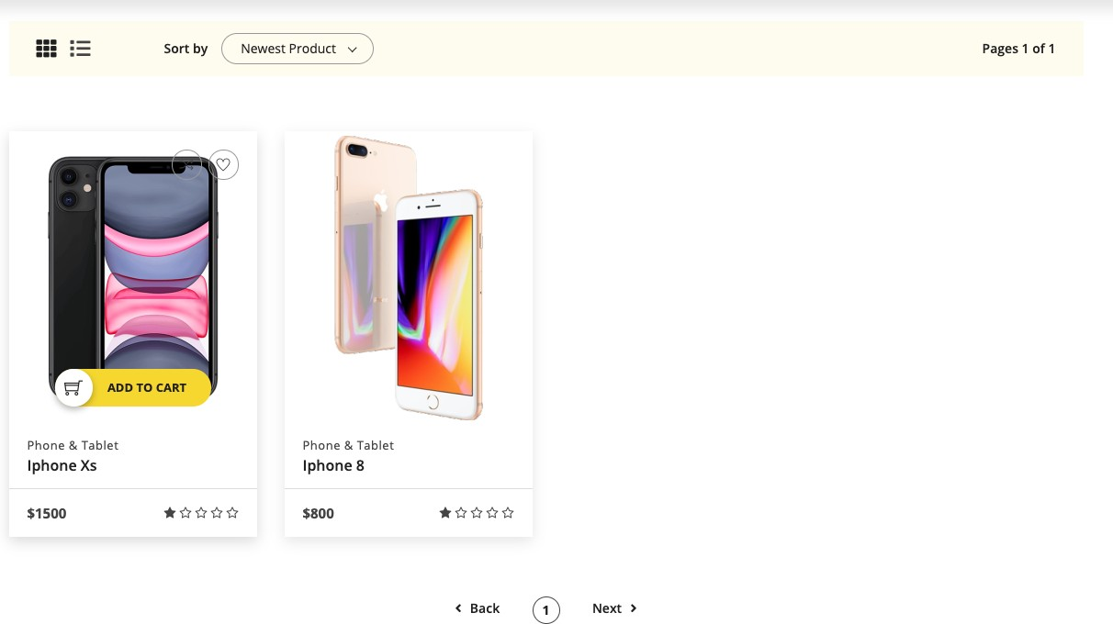

**Figure 34**. Categories Page.

## Best Deal Page

The Best Deal page which is shown in Figure 35 shows to customers that all products are on sale or have the best prices. Products on the highest discount will be time reduce.

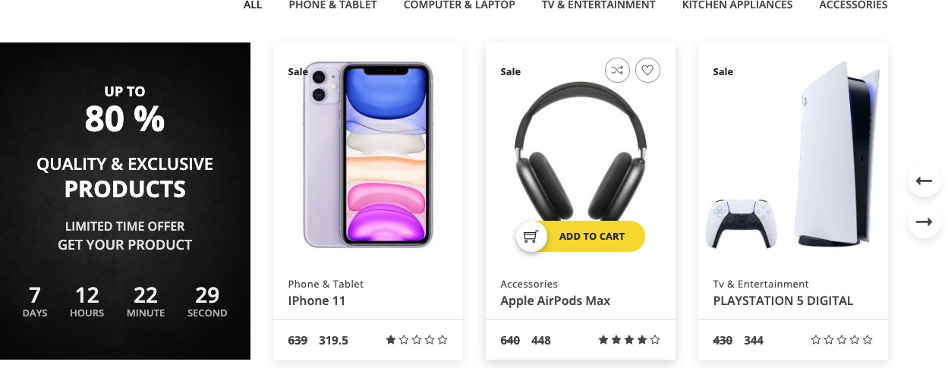

**Figure 35**. Best Deal Page.

## Change Password Page

The Chang password page which is shown in Figure 36 allows user to manage their in- formation data for change password method through web page. The system requires cli- ent who had login already.

Input: old password, new password, confirm password.

Process: The system will check if the username and password are valid.

Output: If the username and password are correct, the information will b. If wrong, the system will request to re-enter.

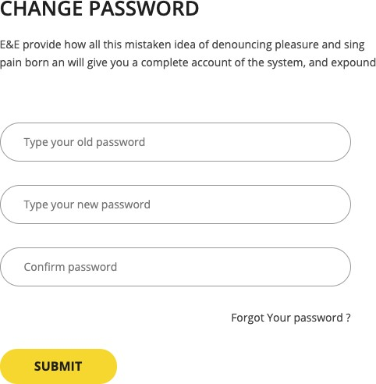

**Figure 36.** Change Password Page.

## Checkout Page

The Checkout page which is shown in Figure 37 allows user to enter their information data for order product through web page. Client can review all products which was or- dered already.

Input: Information fields.

Process: The system will save client information in database. Output: The system will be redirect to payment page.

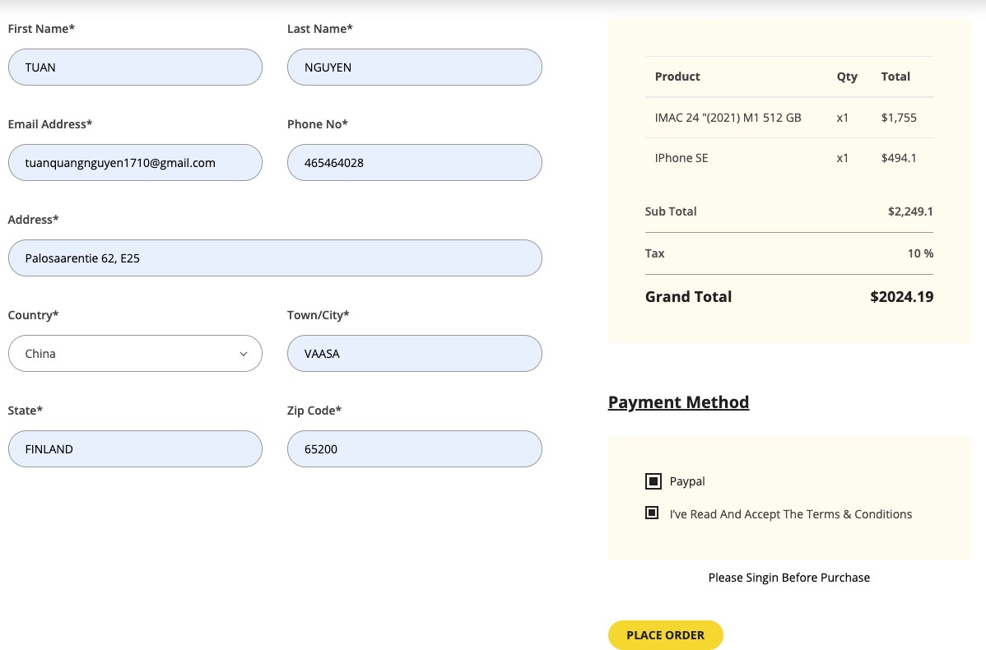

**Figure 37.** Check out Page.

After placing an order, login page to PayPal payment is opened as shown in Figure 38. PayPal allows user to enter their information data for payment through PayPal page.

Client can review the total price to pay. After login to PayPal system will be redirect to payment page and client will receive an email.

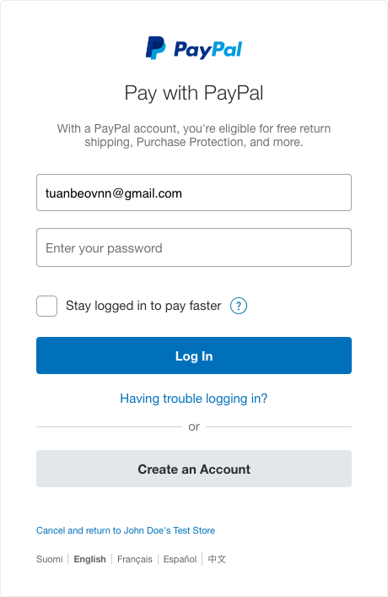

**Figure 38.** Login PayPal

## Customer Pages

## 

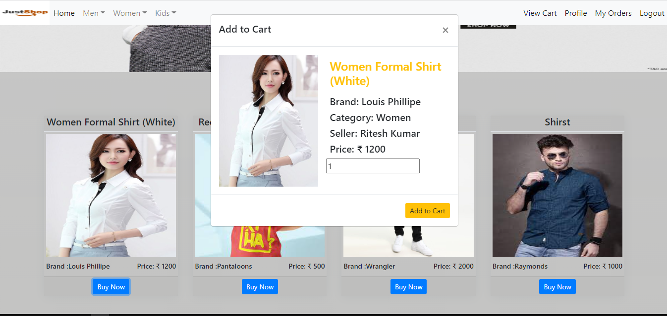

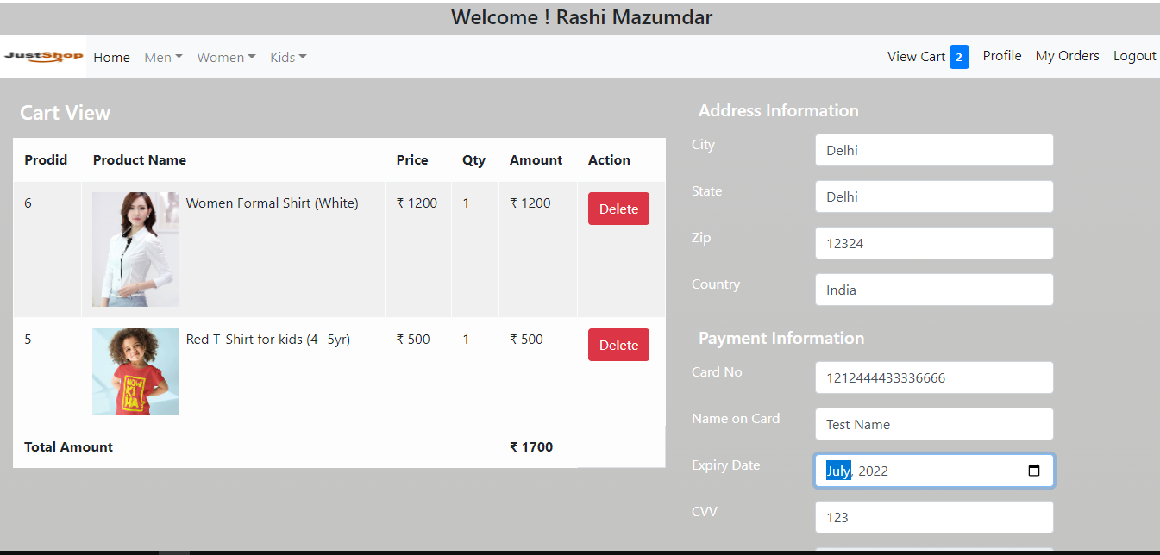

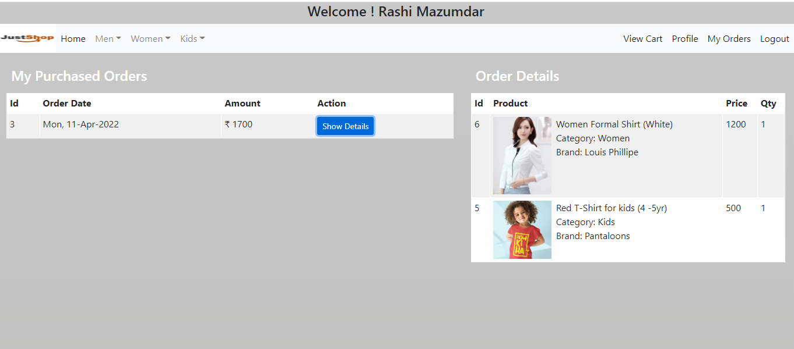

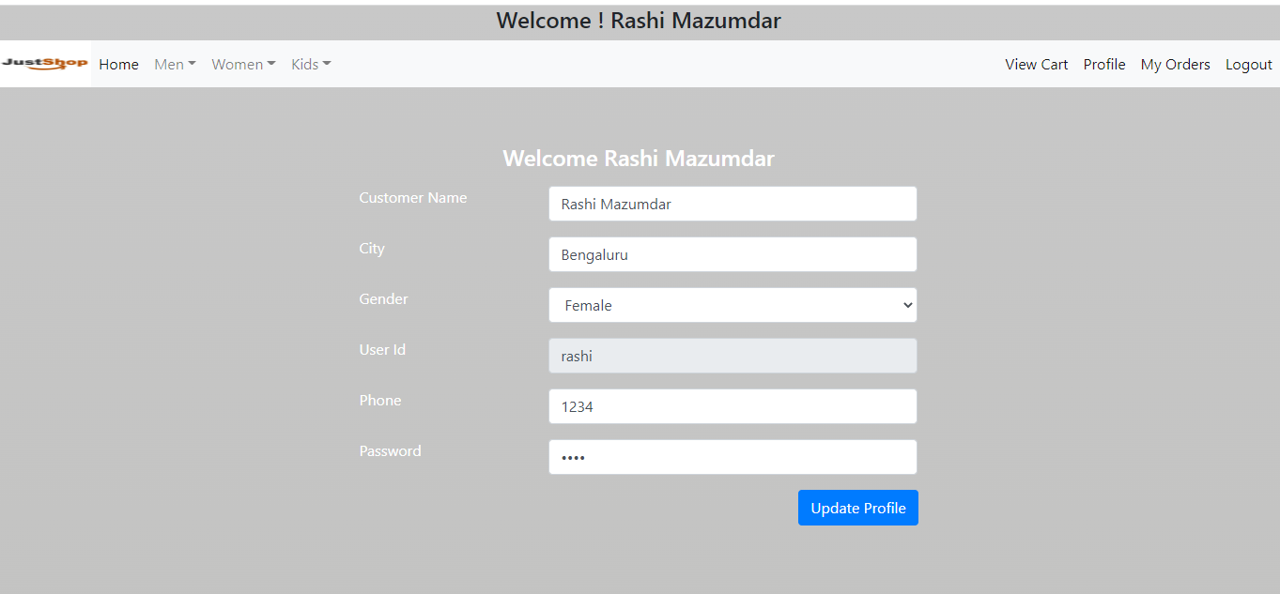

The compare page which is shown in Figure 39 allows user allows users to search and compare the selling price of the products which are interested before making a purchase.

Input: Click to add compare page.

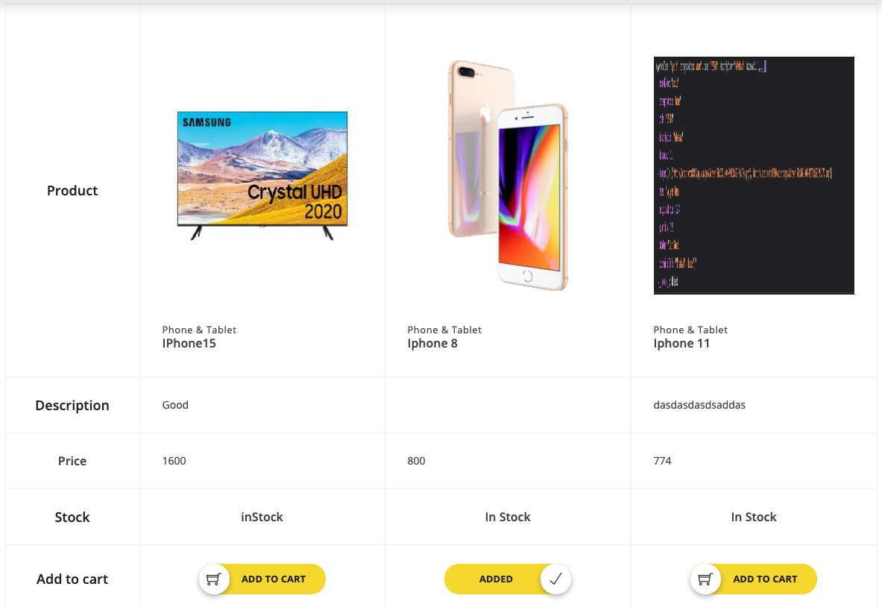

**CHAPTER 6**

**IMPLEMENTATION**

There are many tools used to embed data in DNS queries and responses between the tunneled client and the rogue server that can then forward the data to another destination client DNS tunneling tools.

The Most commonly used DNS tools like DNScat2 that allows two hosts to communicate routing all traffic through DNS. Iodine platform implementation of IPV4 tunnelling data through DNS server. DNS2tcp encapsulateTCP packets over DNStunnels. OzymanDNS to create a SSH tunnel over DNS or for file transfer.

**6.1 Demonstration of DNS Tunneling Tool**

**DNScat2** - The client is designed to be run on a compromised machine. It’s written in C and has the minimum possible dependencies. When you run the client, you typically specify a domain name. All requests will be sent to the local DNS server, which are then redirected to the authoritative DNS server for that domain (which you, presumably, have control of). They’ll be faster, and still look like DNS traffic to the casual viewer, but it’s much more obvious in a packet log (all domains are prefixed with “dnscat.”Unless you hack the source). It can tunnel any data with no protocol attached. Which means it can upload and download files.

**Connecting the client with server using server IP address and domain name (nish.in)**

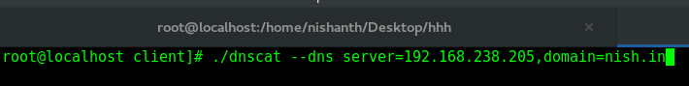

**Server side DNScat2**

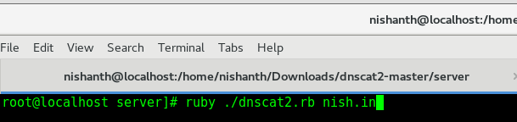

**Connection is established between the server and client.**

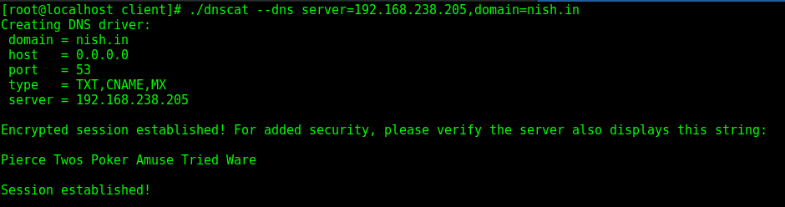

**Tunnel is created and data can we exfiltrated now**

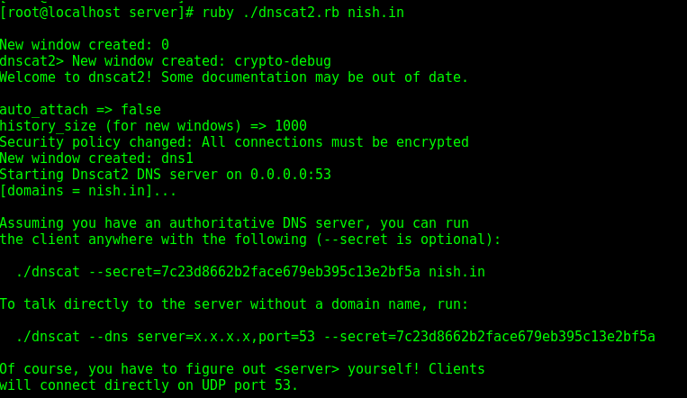

**Creating a session to perform an attack inside the tunnel**

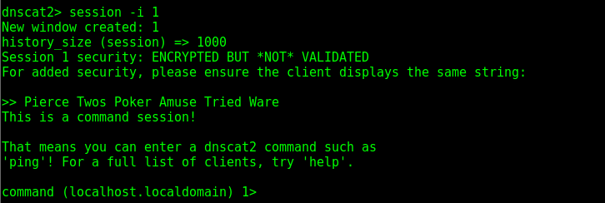

**Uploading file from server to client.**



**Downloading file from client to server.**



**6.2 Detection of DNS Tunneling Attack**

**Traffic analysis**: Traffic analysis is used to detect malicious activity based on multiple requests or overall traffic. Attributes that can be used for traffic analysis include volume of DNS traffic, number of hostnames per domain, geographic location and domain history. Looks at multiple requests/response pairs over time and checking the amount and frequency of requests for a single domain it is possible to spot DNS tunneling activities.

**Wireshark:** An abnormal DNS behavior can have dramatic effects on overall application performance. This is why it is so important to keep an eye on it. DNS traffic at the layer 7, meaning it can clearly identify the DNS query types and related performance metrics.

**Snort:**Snort fills an important ''ecological niche'' in the realm of network security: a cross-platform, lightweight network intrusion detection tool that can be deployed to monitor small TCP/IP networks and detect a wide variety of suspicious network traffic as well as outright attacks.

**6.3 Detection of DNS Tunneling Attack using Wireshark**

We created a tunnel with dnscat2 and analyzing it in the Wireshark.

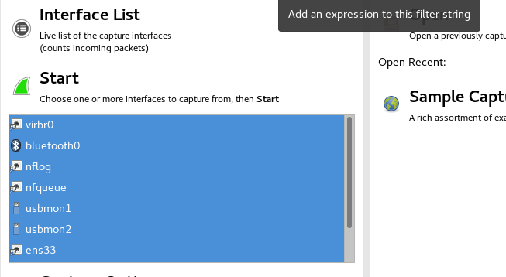

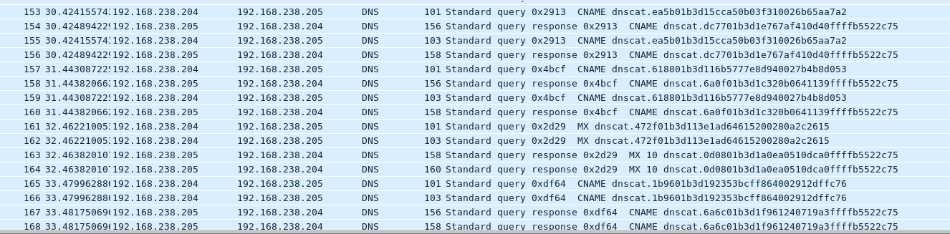

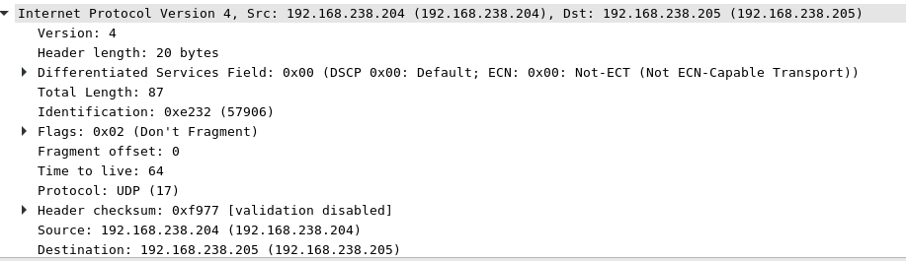

If you notice the traffic you can see the DNScat query packets continuously sent to the victim’s machine

**6.4 Detection of DNS Tunneling Attack using snort**

**Snort**​ ​is the most famous open source Network Intrusion Detection/Prevention System and ability to perform Real-time traffic analysis and logging on IP networks Snort can be configured in three main modes: sniffer, packet logger and network intrusion detection. Sniffer mode does nothing but reading packets from the network and display them on the console, packet logger mode obviously log packets to local disk drive for later analysis and in the third mode the program will monitor and analyze the packets in real-time comparing it to a set of rules defined by the user and perform the specified action on the rule.

Applied Snort Rules for port 53.

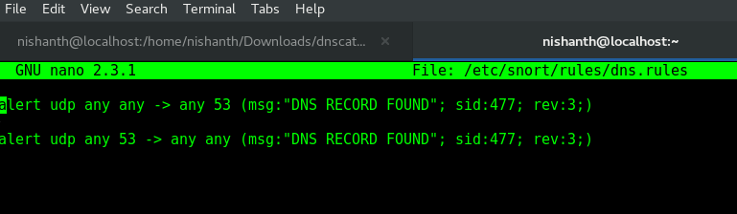

Detecting the DNS Tunneling UDP packets after establishing the connection between server and client.

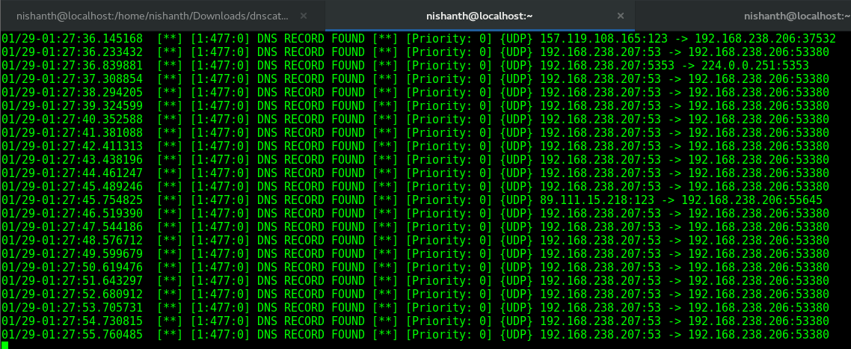

**6.5 DNS Log Analysis**

DNS Analytics allow you to see your domains' query activity as raw data logs or in visual forms such as: line and bar charts, interactive maps, and filterable tables.

* Quickly identify traffic anomalies, like DDoS attacks
* Gather insight into your DNS infrastructure
* Pinpoint system misconfigurations
* Find stale/unused records
* Compare usage trends over time.

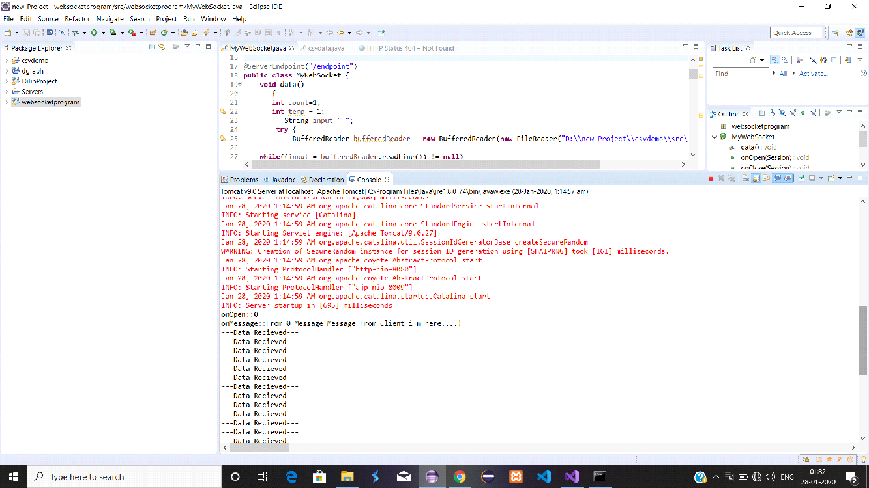

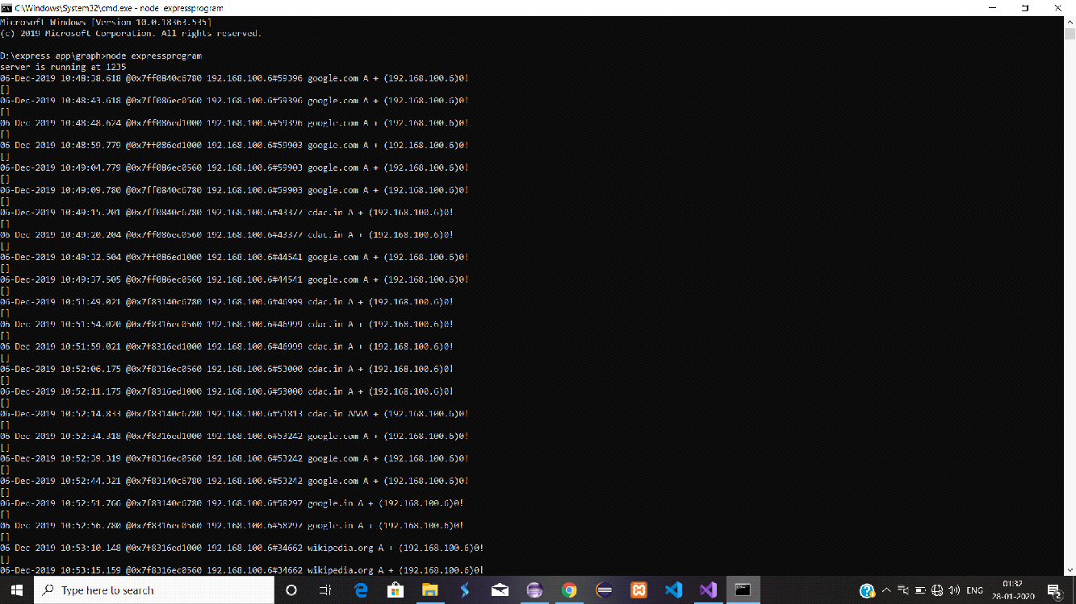

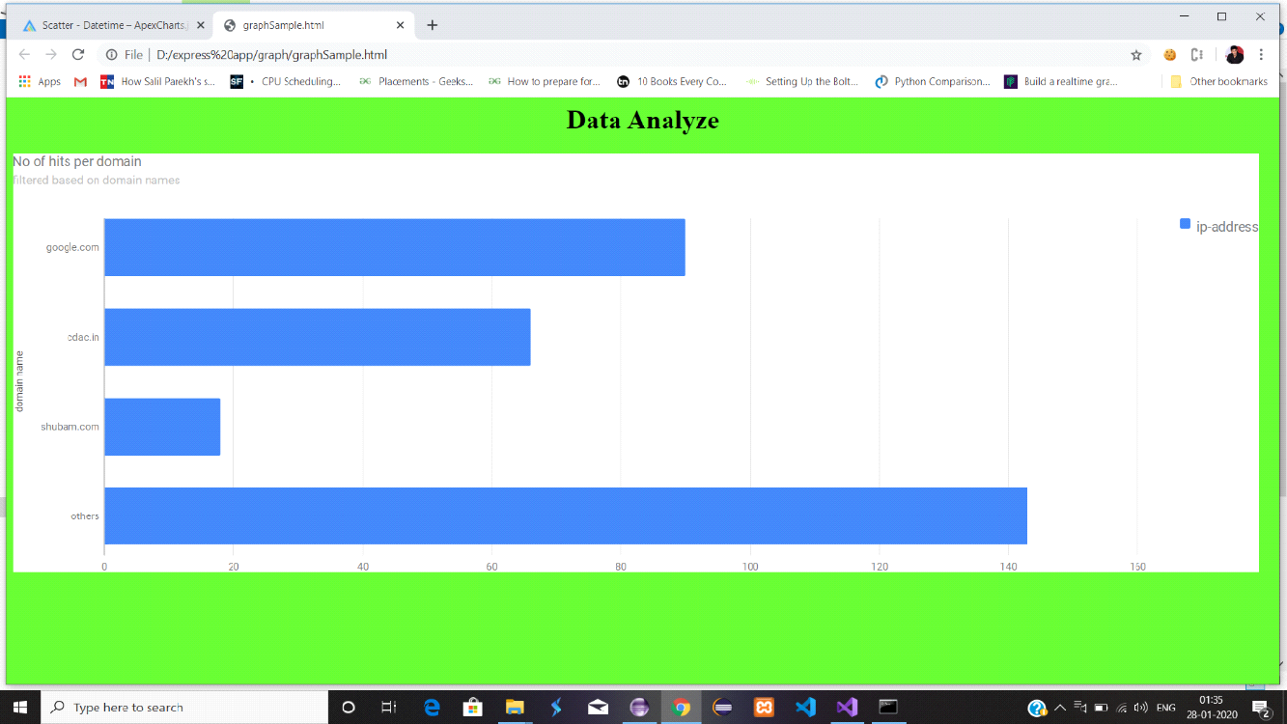

**CHAPTER 7**

**CONCLUSION**

After implementing the topic and systematically presenting the basic contents of ReactJS, Spring Boot, MySQL and a number of other technologies and techniques in building enterprise Java applications on the web, helping to understand overview of Spring Framework as well as the basic principles and working mechanism of this framework. On the other hand, the websites has a three tier web model architecture in Spring. The report gave understanding how the communication mechanism between client and server in modern RESTful service-oriented web model works and how to communication between components of a system.

The websites is built to communicate with the server through a RESTful service with the help of React JS. UI design with Bootstrap with responsive support makes the websites responsive and user friendly. Building a successful e-commerce website with full basic functions so that users can buy product easily. The web application is simple, elegant and functional with important features for an online store.

The theme of E-commerce website is quite popular and highly capable in practical application. However, due to time constrain and less experience the website is developed at the level of completing the requirements of the topic.

**Chapter 8**

**REFERENCES**

* <https://reactjs.org/docs/getting-started.html>
* <https://docs.npmjs.com/packages-and-modules>
* API Development Accessed 22.04.2021. https://swagger.io/
* https://spring.io/projects/spring-boot.
* https://www.tutori alspoint.com/html/
* https://[www.w3schools.com/css/](http://www.w3schools.com/css/)
* Developer Mozilla. 2021. What is JavaScript ?. Assessed 13.05.2021. https://de- veloper.mozilla.org/en-US/docs/Learn/JavaScript/First_steps/What_is_JavaScript
* <https://dev.mysql.com/doc/>
* https://redux.js.org/tutorials/fundamentals/part-6-async- logic